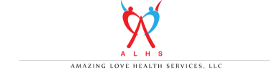
CONSENT TO PARTICPATE IN EMPLOYMENT PROGRAM

I, ______________________________, agree to participate in the Amazing Love Health Services, LLC Rehabilitation Services Administration Employment Program. I agree to participate in the implementation of my Individualized Plan for Employment (IIPE), actively participating in all job search processes within my community.

Person’s Signature Date

Witness Signature Date

This consent is valid for one year from the date of signature.

